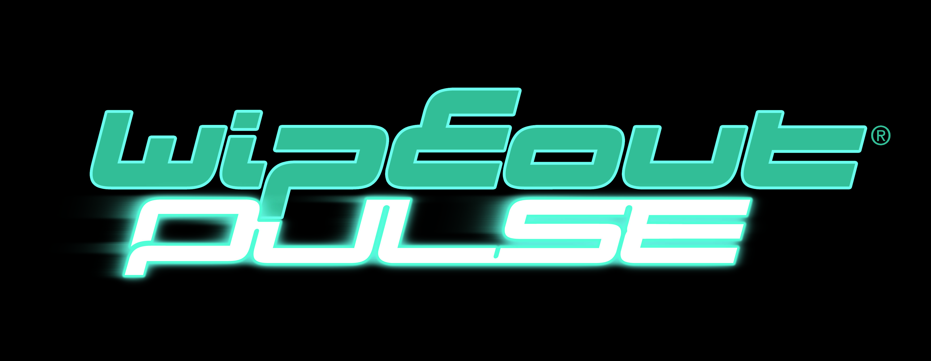

Press Information
For Immediate Release

Feel the Beat with WipEout Pulse this September

- Breathtaking new instalment of the anti-gravity combat racing legend comes to PSP
- 24 new tracks, 8 teams and 7 adrenaline-fuelled game modes
- Wireless multiplayer via Ad Hoc and Infrastructure Mode
- Extensive downloadable packs including new tracks, ships and tunes
- Pumping soundtrack mixed by a range of top artists including Mason, Loco Dice and Stanton Warriors

Sony Computer Entertainment Europe (SCEE) is pleased to announce the upcoming release of WipEout® Pulse for PSP™ (PlayStation®Portable) this September. Developed by SCEE’s award-winning Studio Liverpool, WipEout Pulse brings the iconic anti-gravity combat racing title back to PSP after a two-year wait. Pulse arrives with a full tank of innovation, bringing stylish new tracks, futuristic ships, high-tech weapons and an impressive 7 game modes to the high-octane speed, adrenaline-drenched, anti-gravity 800 kilometres per hour action you’ve come to expect from the series. Built to better even its critically-acclaimed predecessor, WipEout Pulse is set to become an instant classic and a must-have for PSP owners – not least because of its stunning visuals and overall enhanced game package but also its immediate accessibility: a new Training section introduces the player to how the game plays, from ship handling through to weapons allowing it to be accessible to all racing fans looking for an alternative to traditional on-wheel racers.

The wait for WipEout Pulse has been well worth it as Studio Liverpool has been hard at work developing a range of futuristic new features. There are 8 teams including the new EG-X outfit, while new weapons provide all sorts of devious ways to send rivals into a spin. Tracks now contain the brand new Mag-Strip feature which causes ships to become temporarily locked to the track’s surface. This feature offers a huge variety and dynamism in track design and adds incredible racing conditions such as loops, vertical drops and 90 degree angled sections.

Race head-to-head at eye-watering speeds on magnificently-rendered reversible tracks built into a variety of stunning landscapes. Create your own multiplayer events in Ad Hoc and Infrastructure modes – and experience it all to the exhilarating beat of a thumping, fully-licensed soundtrack featuring the latest big names in dance music (full track-list to be announced). There is even the possibility to play your own mp3 files direct from your memory stick! Finally, a wealth of extra downloadable content will be made available at launch and post launch, including new tracks, ships and tunes to add to your racing soundtrack, and – if you’re really impressed with your skills- you can take a snapshot of your ship at any time using Photo Mode and post it online!

With no prizes given for second place, WipEout Pulse – exclusive to PSP – will be unleashed this September and is set to better its critically-acclaimed predecessor WipEout Pure.

Key Features:
  - Latest incarnation of the iconic, stylish and futuristic anti-gravity combat racer: an awesome follow-up to WipEout Pure on PSP
  - Upholds the brand heritage and refines all the best elements of the franchise to deliver an exhilarating racing experience loaded with hi-tech weapons, hi-octane speed and futuristic adrenaline-fuelled combat
  - 7 diversified single player and multiplayer modes, including wireless multiplayer mode via Ad Hoc and Infrastructure Modes
  - Downloadable content available at launch and post-launch: new circuits, ships and music tracks
  - Pumping soundtrack licensed by a range of top artists including Mason, Loco Dice and Stanton Warriors
  - 8 teams including the new EG-X team and 24 new exhilarating tracks
  - New Mag-Strip track feature: Allowing for a huge variety and dynamism in track design including loops, vertical drops and 90 degrees angled sections
  - Snap a photo of your ship at any time in Photo Mode and upload online to show the world

WipEout® Pulse © 2007 Sony Computer Entertainment Europe. Published by Sony Computer Entertainment Europe. Developed by SCEE Studio Liverpool. Wipeout is a trademark of Sony Computer Entertainment Europe. All rights reserved.

Ends
For more information about WipEout Pulse, please contact your local PR manager.

About Sony Computer Entertainment Europe Ltd.
Sony Computer Entertainment Europe (SCEE), based in London, is responsible for the distribution, marketing and sales of PLAYSTATION®3, PlayStation®2 and PSP® (PlayStation®Portable) software and hardware in 102 territories across Europe, the Middle East, Africa and Oceania. SCEE also develops, publishes, markets and distributes entertainment software for these formats, and manages the third party licensing programs for the formats in these territories. Between its European debut on 24th November 2000 and the end of September 2006, over 44 million PlayStation 2 consoles have been shipped across the SCEE territories, over 115 million worldwide, making it one of the most successful consumer electronic products in history. Between its European debut on 1st September 2005 and the end of September 2006, over 8.8 million PSP systems have been shipped across the SCEE territories, with over 24.7 million shipped worldwide since its Japanese launch in December 2004.

More information about PlayStation products can be found at www.playstation.com and www.yourpsp.com or visit the Virtual Press Office at www.scee.presscentre.com.

PlayStation, PSP and the PlayStation logo are registered trademarks of Sony Computer Entertainment Inc. UMD (Universal Media Disc) is a trademark of Sony Computer Entertainment Inc. All other trademarks are property of their respective owners.

